Alumni help center feedback form:

* **Process:**
  + Student fills feedback form
  + Data will be recorded
  + Administrator reviews the data
  + Data will be saved
* **Process flow:**

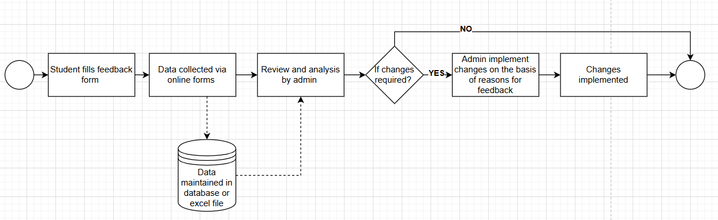

**Feedback form:**

1. Name: ______________________________________________ (optional)
2. Email address: ___________________________________________ (optional)
3. Age: _____ (optional)
4. Any reason for feedback?
   1. General
   2. Complaint
   3. Suggestion
   4. Others (please specify)

________________________

1. Date of interaction/service

_____________________

1. Overall experience

|  |  |  |  |  |
| --- | --- | --- | --- | --- |
| Excellent | Very good | Good | Fair | Poor |
|  |  |  |  |  |

1. Are you a TCF alumni?
   1. Yes
   2. No
2. If yes, then provide your matriculation roll number

__________________

1. Please share your current WhatsApp number (If you don't have your own WhatsApp, please provide a family member's WhatsApp number who can share information with you. If that's not possible, share your active cell phone number. If none of these options apply, write N/A.)

_____________________________

1. Request for the addition of college/ institution/ vocational center (If any?)

____________________________________________________________

1. What are your views about the portal?
   1. Quality of service
   2. Ease of use
   3. Customer support